Title

Design and Implementation of a Shelter Location-Allocation System in Calumpit, Bulacan Using Genetic Algorithm

Bryan Jett T. Calulo Lovely Angeline OL. Cunanan Elijah Iñigo C. Fabian

**Shelter Infos**

***Specify lvl 2 shelter characteristics***

The quality and capacity of shelters directly influence the survivability of displaced individuals. Level 2 shelters are crucial for ensuring prolonged safety, comfort, and sustainability in cases where displaced individuals must stay longer. This is similar to the light, medium, and heavy bomb-proof shelters from World War II, where the severity of the bombing determined the type of shelter civilians would use. In this case, the intensity of the natural disaster plays a similar role (C.G. Flebus, 1941). The following is a breakdown of the characteristics of Level 2 shelters:

**Structural Integrity**

Level 2 shelters are designed to withstand strong winds, earthquakes, and heavy rainfall. Their reinforced structural components ensure long-term durability. They often feature elevated floors or flood-resistant designs to protect against flooding, along with safe rooms for added security during extreme events.

**Capacity and Space**

Level 2 shelters are built to accommodate a larger number of evacuees comfortably for extended periods. This prevents overcrowding and provides functional areas for various needs, such as rest, food preparation, and sanitation. Standards for space allocation ensure that occupants have enough room for safe movement, reducing the risk of diseases associated with cramped living conditions.

**Facilities**

Level 2 shelters are equipped with communal spaces, designated sleeping areas, cooking facilities, and essential utilities such as power and water supplies to meet the basic needs of the occupants.

**Medical Safety Equipment**

The shelters are outfitted with basic medical facilities and safety equipment to provide immediate first aid and care for vulnerable populations, including the elderly, children, and those with pre-existing medical conditions. They are stocked with emergency medical supplies and have designated spaces that can be used for medical treatment.

**Accessibility and Communication**

The shelter's design ensures that individuals with disabilities, the elderly, and children can safely enter and navigate the space. Ramps, handrails, and designated areas for people with disabilities are provided to ensure inclusivity. This is essential to guarantee that all displaced individuals, regardless of physical limitations, can access the shelter and receive aid. Additionally, communication tools such as satellite phones, internet access, and radios are included to facilitate contact with external relief agencies and government bodies.

**Safety and Monitoring**

These shelters are equipped with safety measures, including surveillance systems, security personnel, and monitoring tools, to protect occupants from both internal and external threats.

***Specify shelter resistance characteristics***

**Earthquake Resistance**

The shelter must be constructed with flexible structures designed to absorb and dissipate seismic energy, ensuring stability during earthquakes.

**Flood Resistance**

In flood-prone regions, shelters must be elevated or built with waterproof materials to prevent water intrusion. Barriers around the shelters should mitigate flood risks, and the shelters should be located in areas with the lowest likelihood of rising waters. This is crucial for ensuring long-term habitation during floods.

**Typhoon Resistance**

The shelter must feature aerodynamic roofs and reinforced walls to withstand high winds. Heavy-duty materials should be used to minimize damage from flying debris and strong gusts of wind.

**Area Estimation**

Uses <https://www.mapdevelopers.com/area_finder.php>

Gamit google map data

Common method used by engineers. If want mas accurate use Autocad, but since estimation lang naman, ok nayan

For level 2, times 2 natin area

**Cost Estimation**

For level 1 ,

Improvement/Rehabilitation COst

Cost estimate using IMPROVEMENT OF EXISTING EVACUATION CENTER TO COMPLY WITH THE MINIMUM BASIC FACILITIES; COMFORT ROOMS, COMMUNAL KITCHEN, CLINIC, PLUMBING, TILEWORKS, ELECTRICAL AND PAINTING

<https://t-subaybayan.dilg.gov.ph/projects/37493>

2000000

Divide naten sa lot area

<https://t-subaybayan.dilg.gov.ph/projects/20357>

263 sq m

=7,604.56 or approx. 7700 per sq m

For level 2,

Cost estimate using Frances Evacuation center Contract cost

<https://www.dilg.gov.ph/PDF_File/reportorial/dilg-reportorial-2022712_2b19cd0795.pdf>

8,980,000

Divide naten sa lot area (area sa level 1)

<https://dpwh.gov.ph/dpwh/sites/default/files/webform/civil_works/advertisement/25cc0240_plan-construction_of_multi-purpose_building_at_brgy._francescalumpit_bulacan-c_2-storey300_square_meters.pdf>

150 sq meter

=8980000/150 = 59866.67 or approx. **60000 per sq meter**

For Empty Lots,  
 , Batay sa site nato

<https://www.dotproperty.com.ph/land-for-sale/bulacan/calumpit>

The average price per square meter for land in Calumpit was ₱ 12,511  
  
 = approx. 12500 per sq meter

For lvl1,   
 Level2Cost + 12500 per sq meter  
 For lvl1,   
 Level2Cost* 2 + 12500 per sq meter

**Area Per Individual Estimation**

<https://www.joescorpph.com/safezone-modular-tents-call-now-8730808>

Evacuation tent

Size: 250 x 250 x 150 cm

Capacity: 6 - 8 pax

Approx: 2.5 x 2.5 = 6.25 m squared / 6 = 1.04 or approx 1 sq m per pax

**Empty Lot Identification Strategy**

Ung di bahain using Project NOAH

<https://noah.up.edu.ph/know-your-hazards>

Then check ung malapit sa Mcarthur Hiwar or main roads

**Max Distance Estimation**

Using google map

Longest distance or diameter = 11.38 km or approx. 12km

**Documentation**

**(bago)**

**Genetic algorithm**

**THESAURUS**

**Chromosome :** allocation , solution , individual

**Gene :** community is to shelter, 1 allocation, shelter level assignment

**Population :** group of chromosomes, solutions, allocations, possible solutions

**Generation :** iteration

**The chromosome**

* Integer based
* Composed ng tatlong parts: initial, transfer, shelterlvl depende sa model
* Bakit integer based? Para masatisfy agad ung constraints na kelangan
  + isang shelter per community
  + Isang shelter ang pagtatransferan
  + Isang level lang per shelter
  + Bonus! This way, masasatisfy narin na may iaallocate na shelter at may pagtatransferan at may level ang shelter
* Mas magandang representative sa shelter allocation
* Letting the integer be the index of the allocated shelter
* Mas short ang chromosome since directly nirerepresent ung shelter compare sa binary

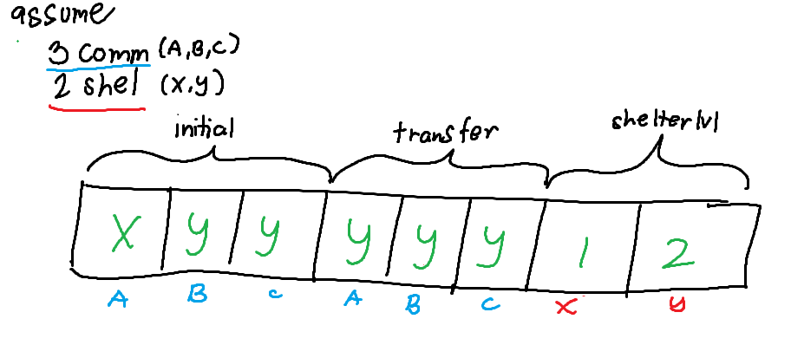

**Spawning**

* spawn()
* Assume N = number of shelters
* Generate ng random number from 0 to N shelter
* Gumawa ng dictionary with format
  + *Community : Shelter*
* I assign ung random number as shelter sa community, ulitin to sa lahat ng community
* If need for shelterlvl, ganto naman format
  + *Shelter : Level*
* Ang level ay random generated den from 1 to 2

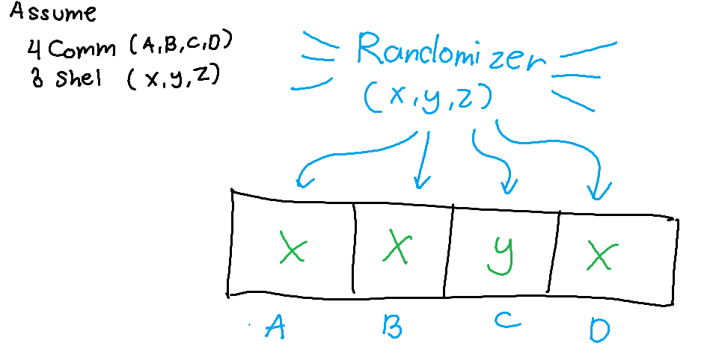

**Selection (Roulette Wheel)**

* selectParent(solutions)
* sumFitness = lahat ng obj. Value
* inverseProportion = sumFitness/fitness, sa bawat solution
* sumInvProportion = lahat ng inverseProportion
* probability = inverseProportion/sumInvProportion, sa bawat solution. Ito magdedetermine ng probability na makukuha ang solution na yon
* Kumuha ng solution batay sa probability. Yun ang atin parent
* Bakit? Kasi madali, directly proportional din ang chance na mapick ang solution batay sa fitness.
* 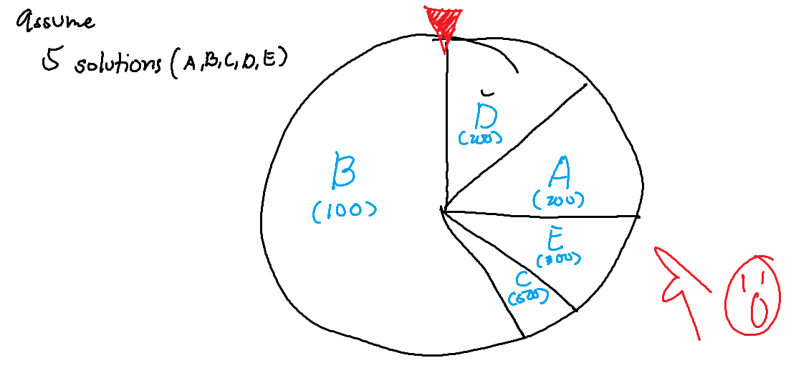

**Crossover (Uniform)**

* generate_offspring(parent1, parent2)
* Allocation ang parent1 at parent2
* Sa bawat community, kunin ang allocated shelter from both parent1 at parent2. Randomly pick doon sa dalawang shelter, yun ang iassign sa community na iyon.
* Ang mabubuong allocation, yun ang magiging offspring
* Bakit? Mas mataas potential diversity compare sa ibang crossover which segmentation ang crossover

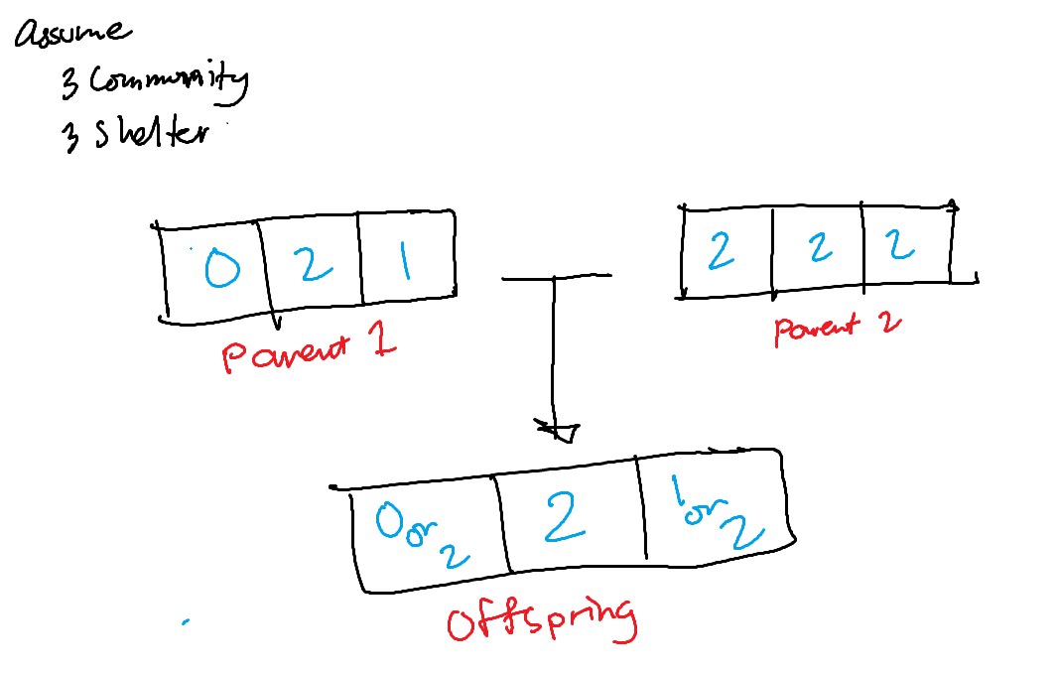

**Mutation (Random Reset)**

* mutate(allocation)
* Kukuha community from allocation, randomly
* Iassign ng shelter randomly maliban sa shelter allocated earlier doon sa napiling community
* Tapos
* Bakit? Madali
* 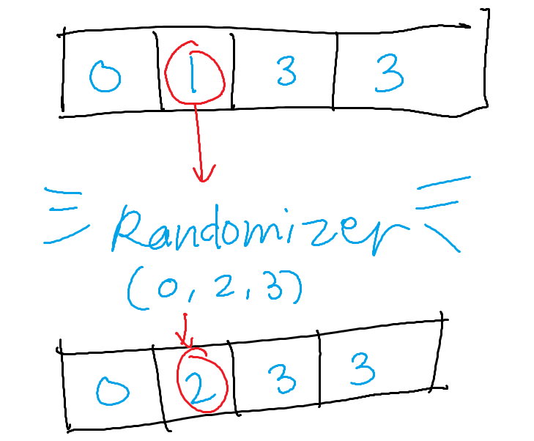

**Feasibility check**

* We need to assume lvl2 >= lvl1
* For distance, for each community, check if there exists distance is less than max distance
* For capacity,
  + check if there exists population * areaPerIndiv < shelter area2
  + check if population sum < sum of top (max shelters) area * areaPerIndiv
    - Lvl 1 shelters and lvl 2 shelters is a subset of shelters
    - cardinality of shelters = max shelters
    - cardinality of lvl 2 shelters = max 2 shelters
    - Pick top (max2 shelters)
    - Pick top (max shelters - max2 shelters) without out level 2 shelters
* Max 2 shelters <= max shelters
* Allocation by minimizing capacity available
  + Sort shelter based on area highest to lowest
  + Sort community based on population highest to lowest
  + Allocate highest community to highest shelter, next shelter if maxdistance fails
  + Proceed to next community, allocate to the available highest capacity
  + Repeat

**Start GA**

* Assume
  + num_generations = X
  + num_solutions = Y
* Spawn Y solutions
* For X iterations:
  + Sort solutions batay sa fitness
  + Select 2 parents, generate offspring, repeat for Y iterations
  + Mutate mga offsprings, if mutation rate
  + Pagsamahin solutions saka offsprings
  + Isort ulit, pick top Y
  + Repeat
* Pick top 1 = best solution

**BNST MODEL**

* Chromosome ay may initial , transfer, shelterlvl

**Fitness**

* First for loop, is kukunin total distance
  + Distance to initial shelter * population at,
  + Distance from initial shelter to transfer shelter * population * portion
* Second for loop, is kukunin cost batay sa level ng mga binuksang shelters
* Add penalty

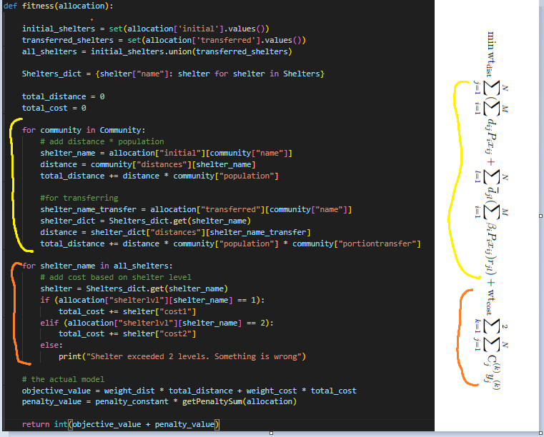

**Constraint 2.2 maximum distance constraint**

* check_max_distance
* For each community, Checheck lang if ung naassign na shelter is mas mataas ang distance from community, doon sa maxdistance ng community
  + then, mag aadd ng penalty, distance - max_distance

**Constraint 2.3 initial capacity constraint**

* check_initial_capacity
* For each, community, kunin muna total ng used_area ng mga shelter batay sa mga naassign na community sa mga shelter.
  + Used_area = population * area_per_individual
* Then check if used_area ng shelter is mas mataas kay area ng shelter
  + Then, mag aadd ng penalty, used_area - shelter_areas

**Constraint 2.4 capacity constraint for transfering**

* check_transferred_capacity
* For each, community, kunin muna total ng used_area ng mga shelter batay sa mga naassign na PAGTATRANSFERAN ng community sa mga shelter.
  + Used_area = population * area_per_individual * portion
* then check if used_area ng shelter is mas mataas kay area ng shelter
  + Then, mag aadd ng penalty, used_area - shelter_areas

**Constraint 2.5 max lvl2 shelters to be constructed/allocated constraint**

* check_max_lvl2_shelters
* Kunin lang total lvl2 shelters na opened
* Check if mas mataas total sa setted max_lvl2_shelters
  + Then, penalty += lvl2_shelters_ctr - max_lvl2_shelters

**Constraint 2.6 max shelters to be constructed/allocated constraint**

* check_max_shelters
* Kunin lang total shelters na opened
* Check if mas mataas total sa setted max_shelters
  + Then, penalty += len(used_shelters) - max_shelters

**Constraint 2.7 only one shelter assigned per community**

* Since integer based chromosome, already satisfied

**Constraint 2.8 only one level per shelter if opened**

* Since integer based chromosome, already satisfied

**Constraint 2.9 shelter transfer**

* Since integer based chromosome, already satisfied

**Constraint 2.10 check if transferred shelter is lvl 2**

* check_transfer_lvl2_shelters
* Kunin lahat ng inopen na shelter for transferring
* Check if meron don ay lvl 1
  + Then, penalty += 1 per shelter na lvl1

**BST MODEL**

* Chromosome ay may initial , transfer, shelterlvl
* Same lang halos sa BNST

**Fitness**

* First for loop, is kukunin total distance
  + Distance to initial shelter * population at,
  + Distance from initial shelter to transfer shelter * population * portion
* Second for loop, is kukunin cost batay sa level ng mga binuksang shelters
* Add penalty



**Constraint 2.13 maximum distance constraint**

* check_max_distance
* For each community, Checheck lang if ung naassign na shelter is mas mataas ang distance from community, doon sa maxdistance ng community
  + then, mag aadd ng penalty, distance - max_distance

**Constraint 2.14 initial capacity constraint**

* check_initial_capacity
* For each, community, kunin muna total ng used_area ng mga shelter batay sa mga naassign na community sa mga shelter.
  + Used_area = population * area_per_individual
* Then check if used_area ng shelter is mas mataas kay area ng shelter
  + Then, mag aadd ng penalty, used_area - shelter_areas

**Constraint 2.15 capacity constraint for transfering**

* check_transferred_capacity
* For each, community, kunin muna total ng used_area ng mga shelter batay sa mga naassign na PAGTATRANSFERAN ng community sa mga shelter.
  + Used_area = population * area_per_individual * portion
* then check if used_area ng shelter is mas mataas kay area ng shelter
  + Then, mag aadd ng penalty, used_area - shelter_areas

**Constraint 2.16 max lvl2 shelters to be constructed/allocated constraint**

* check_max_lvl2_shelters
* Kunin lang total lvl2 shelters na opened
* Check if mas mataas total sa setted max_lvl2_shelters
  + Then, penalty += lvl2_shelters_ctr - max_lvl2_shelters

**Constraint 2.17 max shelters to be constructed/allocated constraint**

* check_max_shelters
* Kunin lang total shelters na opened
* Check if mas mataas total sa setted max_shelters
  + Then, penalty += len(used_shelters) - max_shelters

**Constraint 2.18 only one shelter assigned per community**

* Since integer based chromosome, already satisfied

**Constraint 2.19 only one level per shelter if opened**

* Since integer based chromosome, already satisfied

**Constraint 2.20 check if initial shelter is lvl 1**

* check_initial_lvl1_shelters
* Kunin lahat ng inopen na shelter for initial
* Check if meron don ay lvl 2
  + Then, penalty += 1 per shelter na lvl2

**Constraint 2.21 check if transferred shelter is lvl 2**

* check_transfer_lvl2_shelters
* Kunin lahat ng inopen na shelter for transferring
* Check if meron don ay lvl 1
  + Then, penalty += 1 per shelter na lvl1

**BNT MODEL**

* Chromosome ay may initial, shelterlvl

**Fitness**

* First for loop, is kukunin total distance
  + Distance to initial shelter * population
* Second for loop, is kukunin cost batay sa level ng mga binuksang shelters
* Add penalty

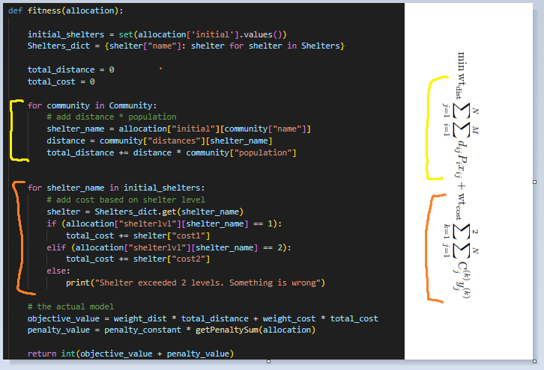

**Constraint 2.24 maximum distance constraint**

* check_max_distance
* For each community, Checheck lang if ung naassign na shelter is mas mataas ang distance from community, doon sa maxdistance ng community
  + then, mag aadd ng penalty, distance - max_distance

**Constraint 2.25 initial capacity constraint**

* check_initial_capacity
* For each, community, kunin muna total ng used_area ng mga shelter batay sa mga naassign na community sa mga shelter.
  + Used_area = population * area_per_individual
* Then check if used_area ng shelter is mas mataas kay area ng shelter
  + Then, mag aadd ng penalty, used_area - shelter_areas

**Constraint 2.26 max lvl2 shelters to be constructed/allocated constraint**

* check_max_lvl2_shelters
* Kunin lang total lvl2 shelters na opened
* Check if mas mataas total sa setted max_lvl2_shelters
  + Then, penalty += lvl2_shelters_ctr - max_lvl2_shelters

**Constraint 2.27 max shelters to be constructed/allocated constraint**

* check_max_shelters
* Kunin lang total shelters na opened
* Check if mas mataas total sa setted max_shelters
  + Then, penalty += len(used_shelters) - max_shelters

**Constraint 2.28 only one shelter assigned per community**

* Since integer based chromosome, already satisfied

**Constraint 2.29 only one level per shelter if opened**

* Since integer based chromosome, already satisfied

**WORK MODEL**

* Chromosome ay may initial only

**Fitness**

* First for loop, is kukunin total distance
  + Distance to initial shelter * population
  + Under that, may isa pang for loop for each work, kukunin total work distance
    - Workdistance batay sa assigned shelter * portion * population
* Second for loop, is kukunin cost batay sa level1 ng mga binuksang shelters
* Add penalty

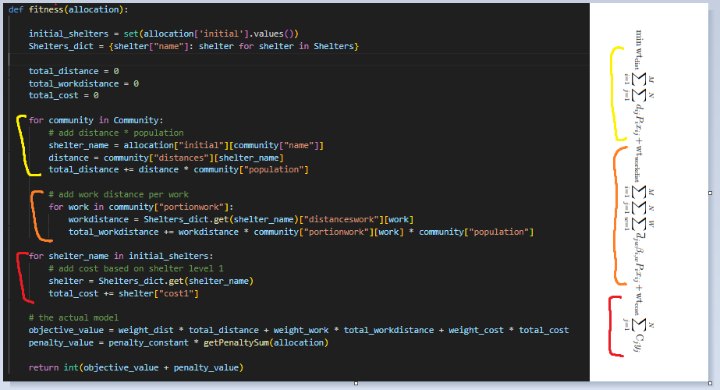

**Constraint 2.32 maximum distance constraint**

* check_max_distance
* For each community, Checheck lang if ung naassign na shelter is mas mataas ang distance from community, doon sa maxdistance ng community
  + then, mag aadd ng penalty, distance - max_distance

**Constraint 2.33 initial capacity constraint**

* check_initial_capacity
* For each, community, kunin muna total ng used_area ng mga shelter batay sa mga naassign na community sa mga shelter.
  + Used_area = population * area_per_individual
* Then check if used_area ng shelter is mas mataas kay area ng shelter
  + Then, mag aadd ng penalty, used_area - shelter_areas

**Constraint 2.34 max shelters to be constructed/allocated constraint**

* check_max_shelters
* Kunin lang total shelters na opened
* Check if mas mataas total sa setted max_shelters
  + Then, penalty += len(used_shelters) - max_shelters

**Constraint 2.35 only one shelter assigned per community**

* Since integer based chromosome, already satisfied